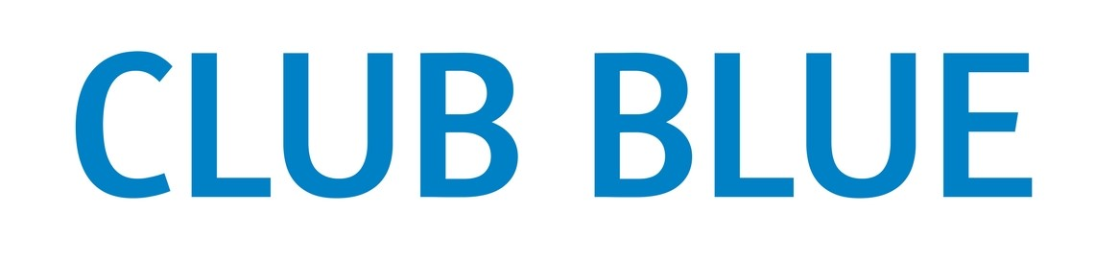 Interest Form 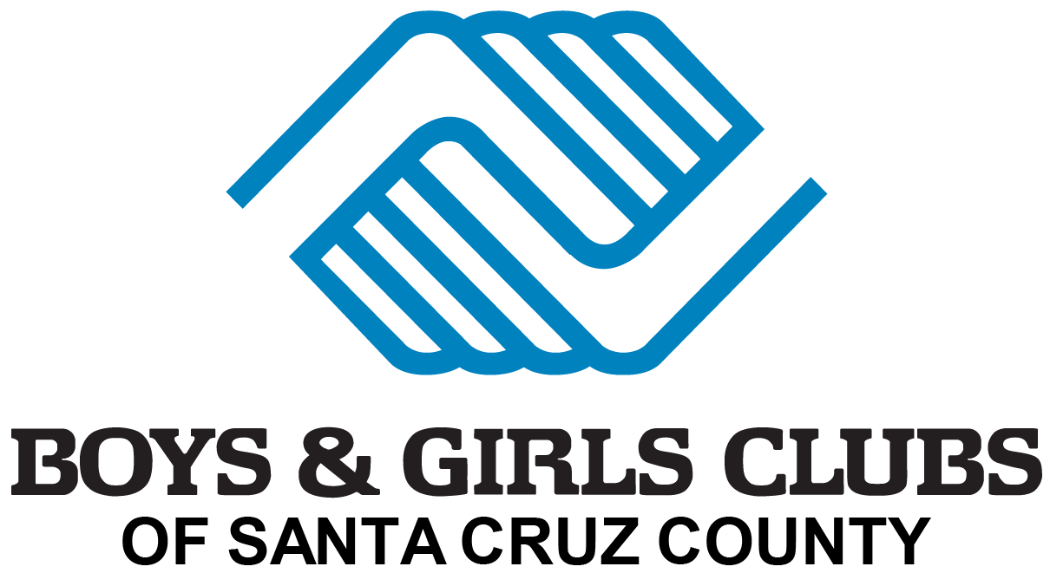
Club Blue is a young professional's group for members to commit their time, resources, and support to Boys & Girls Clubs of Santa Cruz County.

What skills and resources can you contribute?
- Time/volunteer hours
- Programming (youth development)
- Fundraising efforts
- Networking
- Donors
- Other: ______________

What skills would you like growth in?
- Fundraising
- Donating
- Youth development
- Other:_________________________

Where do your expertise and skills contribute to BGCSCC 5 Core areas?
- Education and Career Development
- Character and Leadership Development
- The Arts
- Health and Life Skills
- Sports, Fitness, and Recreation

Contact Information
Name: _______________________
Email: ______________________
Phone:___________________
Organization:__________________________

** We have a private Facebook Group for Club Blue Members, Alexandra will contact you to add you to the group.

